Name: ______________________________ Date: __________________

Point values are assigned for each question. Points earned: ____ / 100

Consider the following graph:

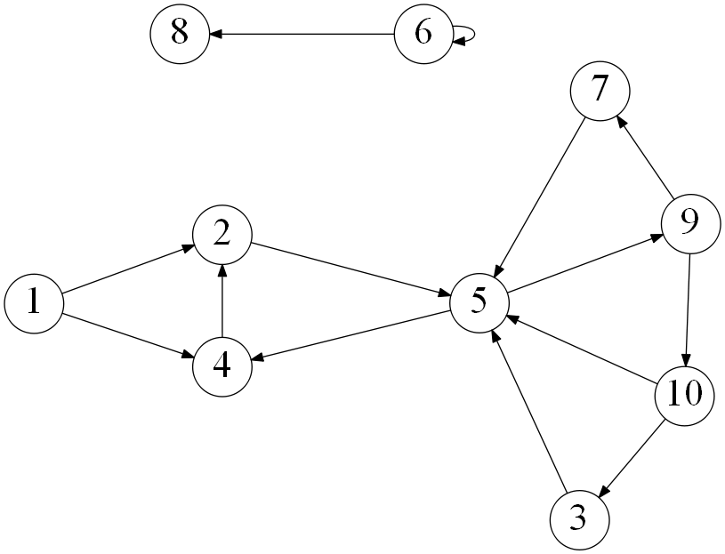

1. Draw how the graph would look if represented by an adjacency matrix. You may assume the indexes are from 1 through 10. Indicate 1 if there is an edge from vertex A -> vertex B, and 0 otherwise. (10 points)
2. Draw how the graph would look if represented by an adjacency list. You may assume the indexes are from 1 through 10. (10 points)
3. List the order in which the vertices are visited with a breadth-first search. If there are multiple vertices adjacent to a given vertex, visit the adjacent vertex with the lowest value first. (10 points)
4. List the order in which the vertices are visited with a depth-first search. If there are multiple vertices adjacent to a given vertex, visit the adjacent vertex with the lowest value first. (10 points)
5. a) What is the running time of breadth-first search with an adjacency matrix? (5 points)

b) What is the running time of breadth-first search with an adjacency list? (5 points)

1. a) What is the running time of depth-first search with an adjacency matrix? (5 points)

b) What is the running time of depth-first search with an adjacency list? (5 points)

1. While an adjacency matrix is typically easier to code than an adjacency list, it is not always a better solution. Explain when an adjacency list is a clear winner in the efficiency of your algorithm? (5 points)
2. Explain how one can use a breadth-first to determine if an undirected graph contains a cycle. (10 points)
3. On undirected graphs, does either of the two traversals, DFS or BFS, always find a cycle faster than the other? If yes, indicate which of them is better and explain why it is the case; if not, draw two graphs supporting your answer and explain the graphs. (10 points)
4. Explain why a topological sort is not possible on the graph at the very top of this document. (5 points)

Consider the following graph:

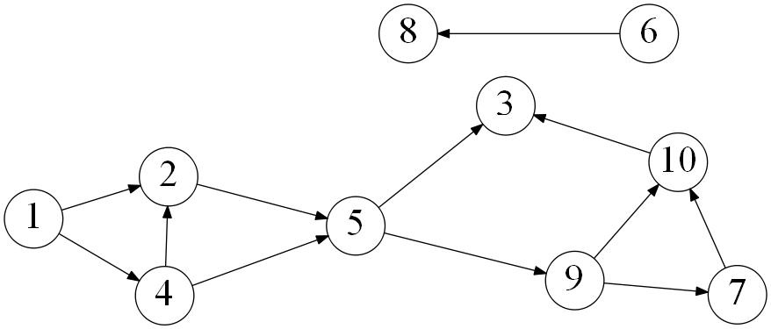

1. List the order in which the vertices are visited with a topological sort. Break ties by visiting the vertex with the lowest value first. (10 points)